OUTPUT:
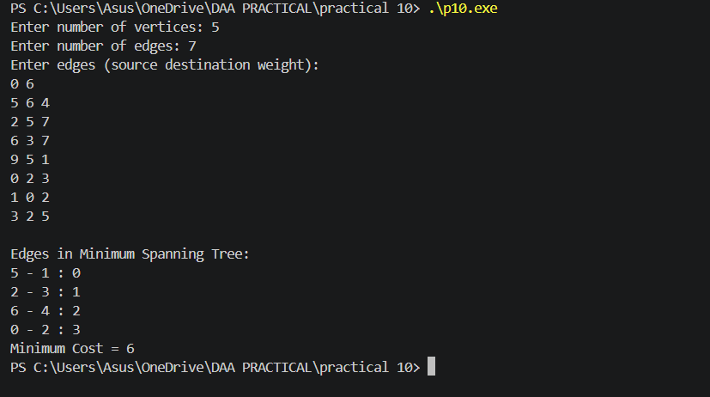

CONCLUSION:
Thus, Kruskal’s Algorithm was successfully implemented to find the Minimum Spanning Tree (MST) of a weighted graph. The algorithm selects the minimum-weight edges while avoiding cycles and obtains the minimum total cost.

